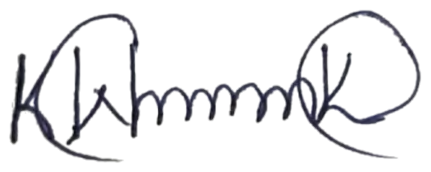
hdel
Karen Wanjiru Kimani

P.O BOX 6377-00300,

Nairobi, Kenya

Email: karenconservation@gmail.com
Tel: +254720396084

26
th
Feb, 2025

Dear
Milan Wan
j
a
,
RE:
TREE NURSERY LAUNCHING.

Karen Forte Environmental Conservation Foundation Organisation, under the leadership of
their CEO, Karen Kimani, have been planting and growing trees across the country for
several years.

Through the help of The Kenya Forest Service (KFS), we are moving our 60K capacity tree
nursery to a new location in Ngong Road Forest, Miotoni block which has been provided by
KFS.
Kereita Forest 500 Tree Planting Exercise in Lari Constituency: 26th February 2024.
One hundred (150) Fruit Tree Planting (growing) Action.Venue:- Statehouse Primary School 28th Nov 2024

We are inv
iting you to our new and bigger tree nursery launching on Saturday, 7/05/2025
starting at 9:00am.

Your presence will be highly appreciated.

Yours faithfully,

Karen Kimani

